**CRIME MANAGEMENT SYSTEM**

**A PROJECT REPORT**

**Submitted by**

**DHRUV SHARMA**

**(2016732)**

*in partial fulfilment for the award of the degree*

*of*

**BACHELOR OF TECHNOLOGY**

*in*

**CSE**

**GRAPHIC ERA**

**DEEMED TO BE UNIVERSITY**

**2020-24**

JULY-2022

**CERTIFICATE**

**Certified that this project report “CRIME MANAGEMENT SYSTEM” is the Bonafide work of ‘DHRUV SHARMA' who carried out the project work under my supervision.**

|  |
| --- |
| **(GUIDE)**  **Mr. AKSHAY RAJPUT** |

**COMPUTER SCIENCE ENGINEERING**

**GRAPHIC ERA DEMMED TO BE UNIVERSITY**

**Acknowledgement**

The project becomes a reality with the support of many individuals. I would like to extend my sincere thanks to all of them.

Foremost, I want to offer this endeavour to our GOD Almighty for the wisdom he bestowed upon me, the strength, peace of mind, and good health in order to finish this project.

I would like to express my gratitude towards my family and friends for their encouragement and support which helped me in the completion of this project.

I would like to thank particularly my project mentor Mr. Akshay Rajput for his support, patience and encouragement throughout the completion of this project.

At last, I would like to thank all the other individuals who helped me in the completion of the project in one way or another.

Dhruv Sharma

2016732

Sec C

**Problem Statement**

**Crime Logger:** Here I have to make a Crime management system application that helps to keep a record of the criminals and their crimes and also manages the record of the officers, their post & the place of their posting. I have used java for the front-end part of the application and MySQL for the purpose of the database.

**Motivation**

As a student, my main motive of taking this project was to learn about new and different things in the Web Development. The name and basic idea of the project also motivated me to choose this project i.e., ‘Crime Logger’. This project was a great opportunity to explore, understand and implement the knowledge of Web Development

***INTRODUCTION***

This is the login page of the system. A user can be either a commissioner or an inspector. This is the database I’ve fed into the system.

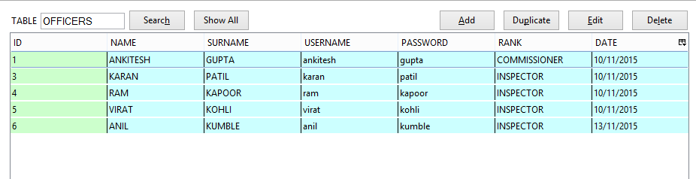

Suppose an Inspector inputs his credentials into the system. He would be taken to the following page.

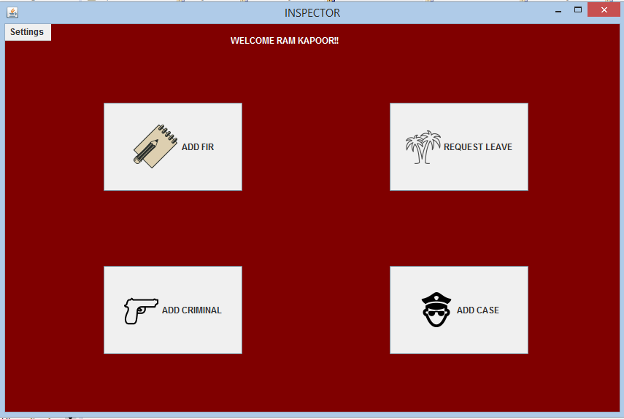

**Here he can do any of the four tasks which are very essential in every police station.**

1. ADD FIR
2. Request leave
3. ADD criminal : he can enter criminal Details
4. Or he can add a new case.

**ADD FIR** :

On clicking add fir the inspector is expected to fill these fields. 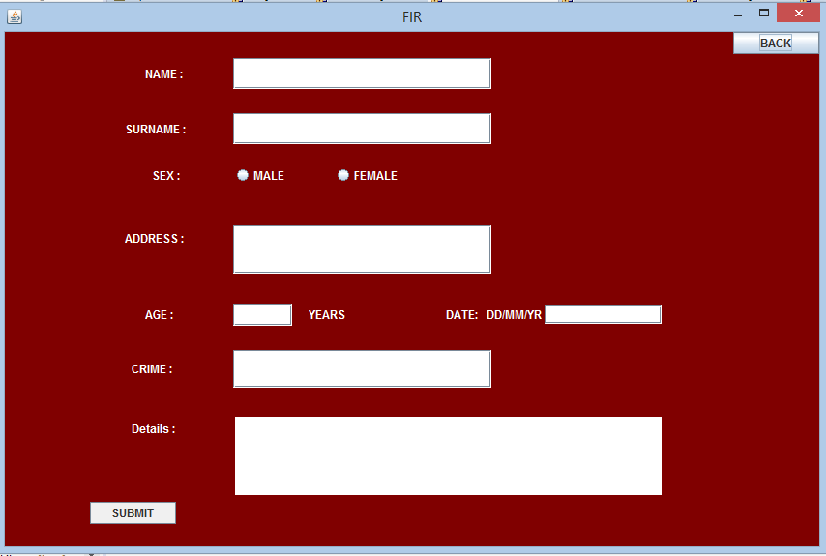

***Request Leave*** : An inspector can also request for a paid leave.

***Add Criminal*** : The police can add an entry of a new criminal by navigating to ADD CRIMINAL

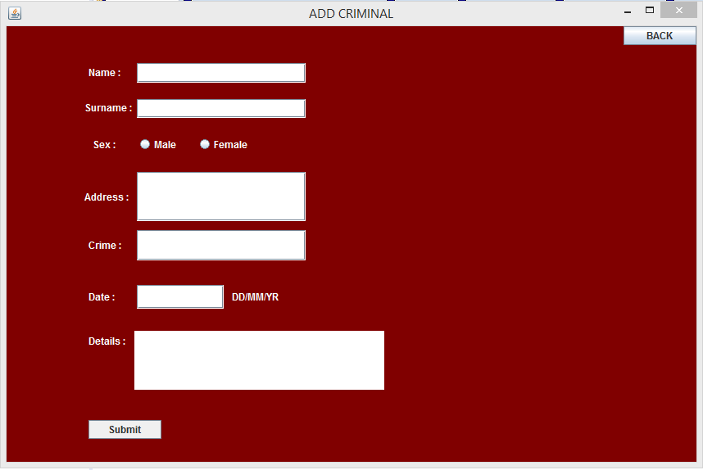

***Add Case***: They can also add a new case in their database by clicking add case

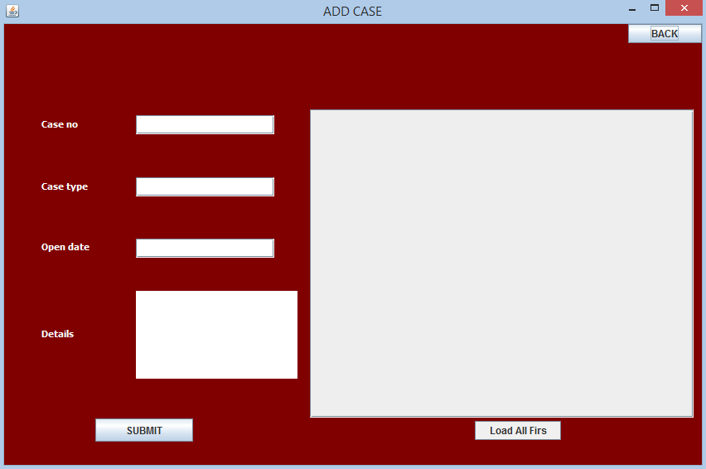

As it happens frequently at police stations that when a person registers an FIR, the FIR can be solved in many ways and even through the means of mutual settlement. When FIR isn’t solved it becomes a case. So this system facilitates the policeman to load cases from current FIR’s without referring to the main FIR file and makes it more convenient for the policeman.

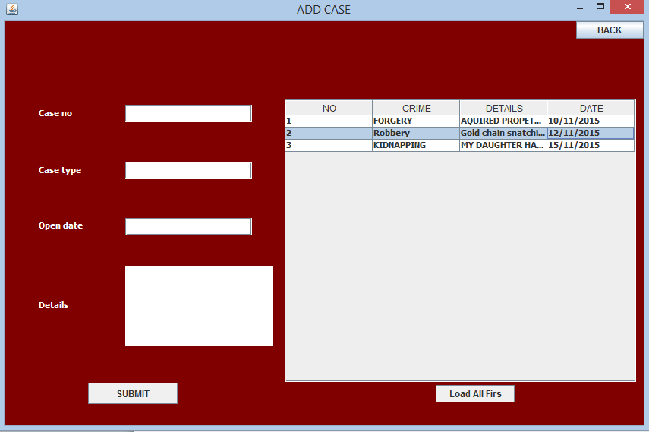

A commissioner at the police station is required to monitor all the cases at the police station. His main tasks include closing a case, to add a new police officer, to transfer an officer or to search the database for any other investigations.

When a commissioner signs in into the system he is taken to the following page.

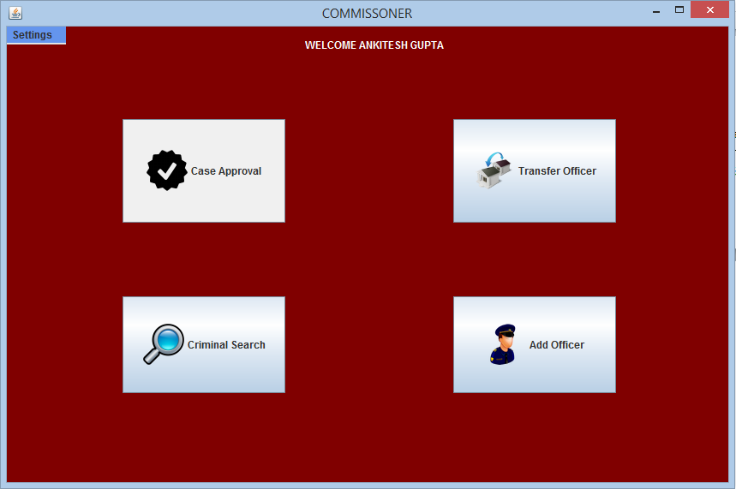

**On clicking case approval:**

Here he can close a case by referring to the file or by simply clicking load all cases.

After all cases are presented to him, he can see the status as C or O describing closed or open respectively.

On finding his intended case, he can enter the case number and close the case.

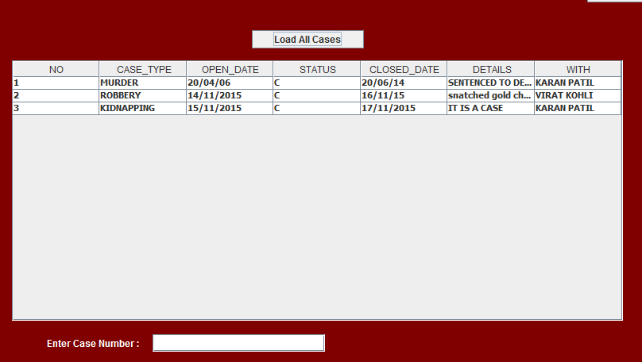

As stated earlier, the commissioner can also transfer officers in the hierarchy lower to him.

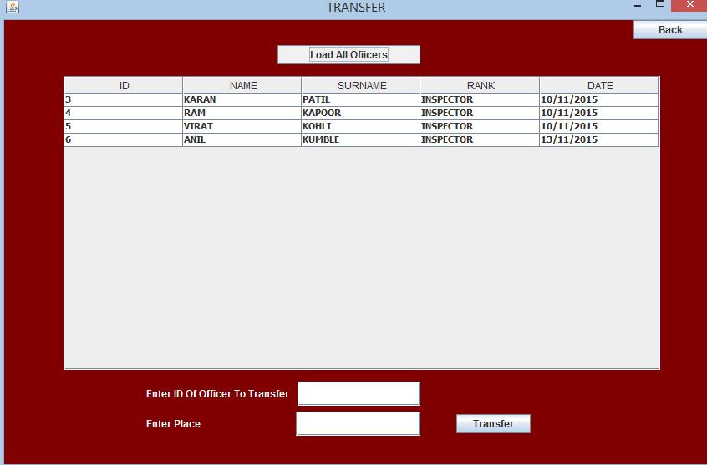

Or look for criminal records

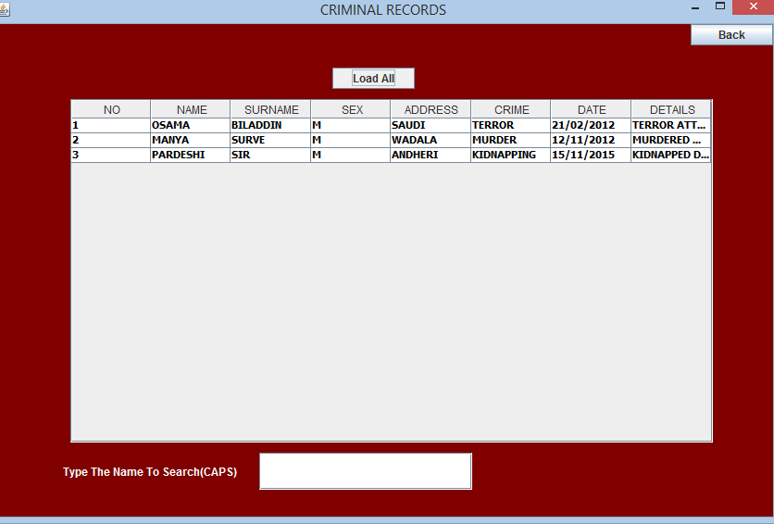

And he can also make an entry for a new hired police officer.

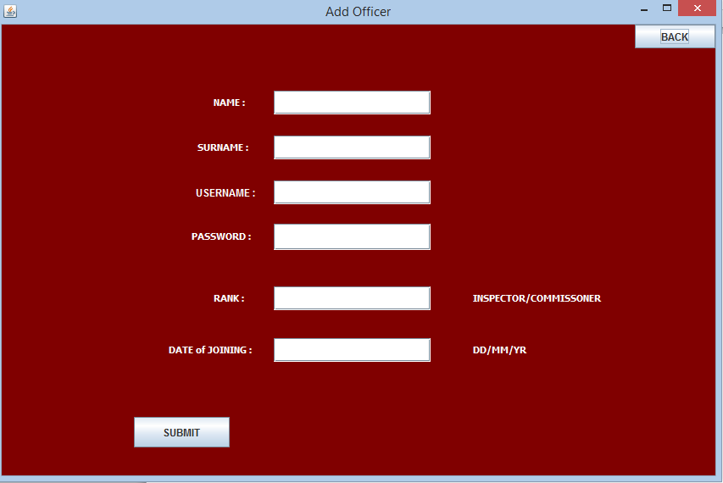

**Requirements**

1. Basic knowledge of Java – Basic Knowledge of Java programming language is a must.
2. Knowledge of AWT and Swing in Java for the front-end development
3. Basic knowledge of MySQL for the purpose of Database in backend
4. Java IDE (Eclipse, NetBeans etc.).

**Conclusion**

In this project, we successfully created a Crime Management System application that maintains the records of the criminals and their crimes and also manages the record of the officers, their post & the place of their posting. We learned how to create a responsive application using java, awt and Swing. We also learnt how the front-end part of the application is connected to the Database using MySQL. I learnt various things from this project which includes learning new sub-classes of awt as well as of Swing. Overall, the project was fun, and I had a good understanding of the topic.

**References**

1. google.com
2. youtube.com
3. geeksforgeeks.org